# Proposed Tunnel Expansion

How do you enjoy walking to class when it’s pouring with rain, or the wind chill is -5 F (-20 C)? Is it fun traipsing through snow or slush? No! And, with an increasing number of international Huskies from warmer climates, the desire for an extension of the tunnel system has been growing. *(For a browsable version of this map, follow this* [link](https://drive.google.com/open?id=1l18DCx827hvqaif5sndVLoqd6CxdOPIU&usp=sharing)*)*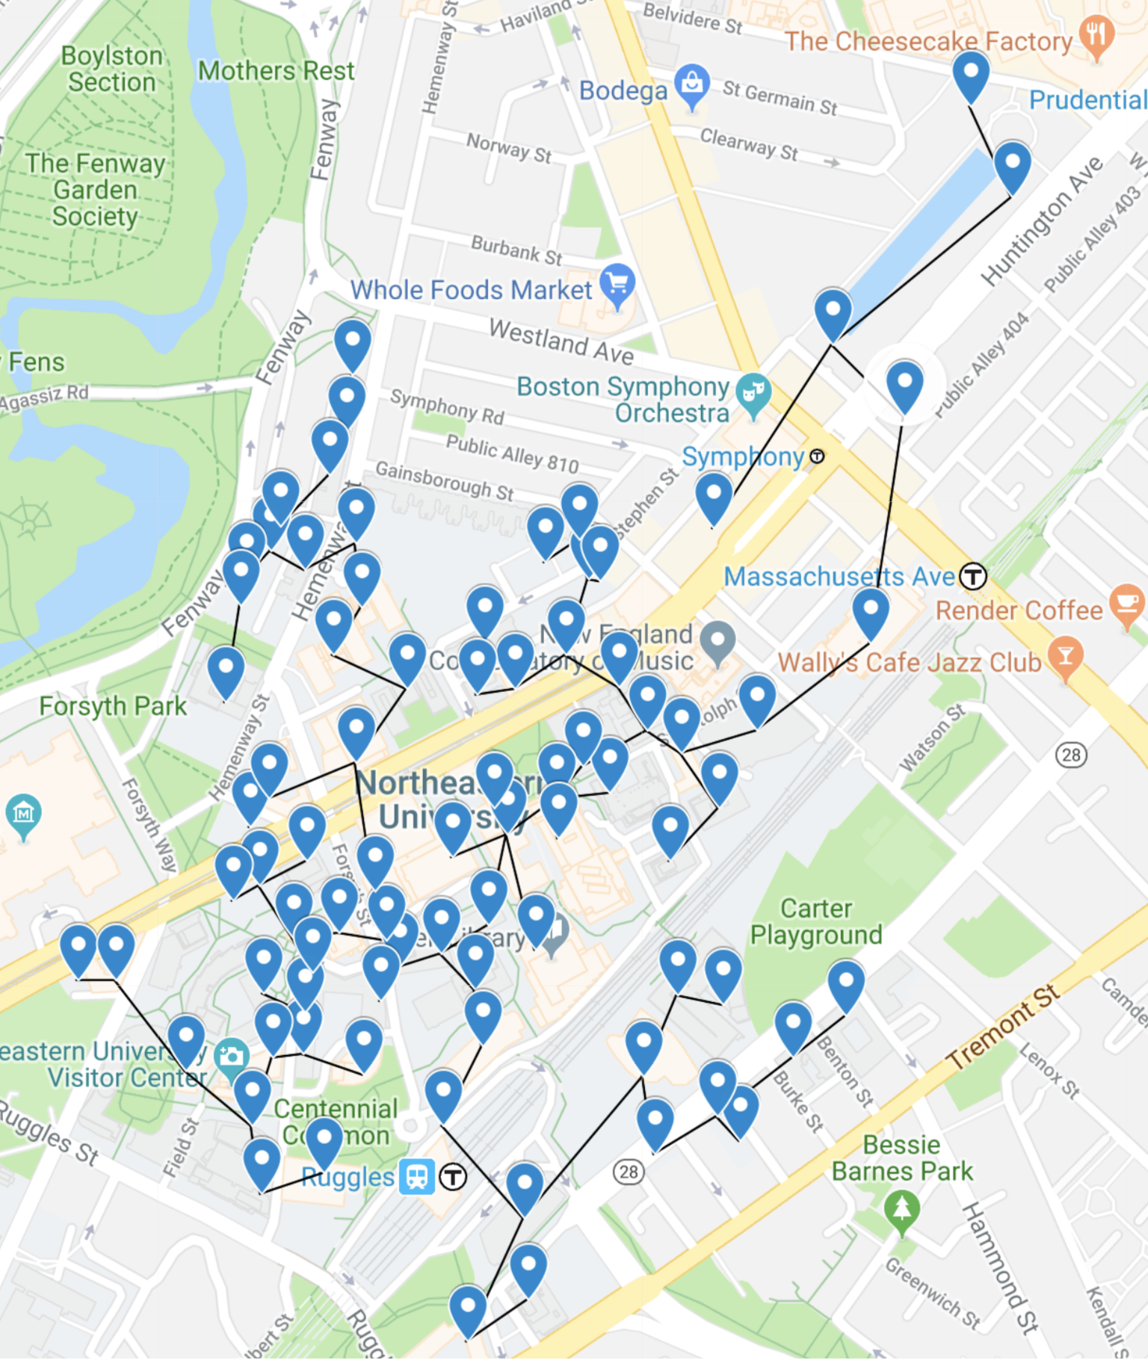

Enter Professor of Civil Engineering Barry Brunel, the great-great-great-great-grandson of the famous Anglo-French tunnel engineer Marc Isambard Brunel and great-great-great-grandson of the even more famous Isambard Kingdom Brunel. Prof. Brunel’s novel tunneling technique is designed especially for pedestrian tunnels. A U.S. patent is held for this technique by Northeastern University. Essentially, the TBM (tunnel boring machine) bores a tunnel of 3.1415927m diameter but only a portion of the spoil is extracted from the ground. The rest is mixed with a bonding agent (the “secret sauce”) and laid down as the floor of the new tunnel. This process reduces the overall cost of tunnel building from a very approximate comparable cost of $1.50 per mm for a tunnel of this size to $1 per mm.

Says Prof. Brunel, “A large part of the cost of constructing this sort of tunnel is essentially wasted: dirt must be extracted and then a floor must be put in. Our way of doing it, uses some of the dirt *for* the floor.”

Nevertheless, this figure is likely to be increased significantly for building tunnels under the railroad, Huntington Avenue, and other major city streets. This is because such tunnels will need to be significantly deeper, requiring more complex ventilation systems and stronger concrete tubes. Additionally, the infrastructure at buildings to reach these deeper tunnels will be much more expensive. For example, the project cost for a tunnel between the Architecture Studio and the Renaissance Park Garage (connecting both sides of the railroad) is $348,035 for a length of 116m.

President Aoun and the Trustees of the University have authorized a study of the feasibility of a tunnel expansion project to be constructed in three phases. Below are some of the early designs for a network connecting all 80 buildings of the University (including parking garages).

In order to save on tunneling expenses, the buildings will be connected based on the concept of a Minimum Spanning Tree (MST), similar to the existing tunnel network (which of course will form the basis of the new system). Each building is connected to just one system, there are no loops, and the total cost of the network is minimized. The overall cost of all three phases is estimated to be in the region of $6.7M for a total tunnel length of 5.274 km. Fundraising has begun in earnest via a GoFundMe page.